1. Use the below table for the following Questions.

|  |  |  |  |  |  |  |  |
| --- | --- | --- | --- | --- | --- | --- | --- |
| **Roll No.** | **Name of the student** | **Sub-1** | **Sub-2** | **Sub-3** | **Sub-4** | **Sub-5** | **Sub-6** |
| 100101 | Rohan | 72 | 55 | 52 | 69 | 95 | 32 |
| 100102 | Mohan | 65 | 51 | 63 | 85 | 71 | 69 |
| 100103 | Ravi | 72 | 56 | 78 | 85 | 47 | 68 |
| 100104 | Ruby | 68 | 71 | 85 | 84 | 78 | 60 |
| 100105 | Radhika | 80 | 78 | 58 | 65 | 68 | 45 |
| 100106 | Rakhi | 61 | 78 | 45 | 62 | 75 | 64 |
| 100107 | David | 78 | 69 | 96 | 52 | 63 | 87 |
| 100108 | Monika | 96 | 85 | 86 | 84 | 45 | 63 |
| 100109 | Tommy | 75 | 63 | 54 | 63 | 61 | 98 |
| 100110 | Rakesh | 63 | 52 | 96 | 87 | 78 | 45 |

1. Find the Minimum Marks and Maximum marks scored by each student.

Ans : Use the Formula MIN( ) for finding minimum values and MAX( ) for maximum values.

1. Calculate the totals for each student, use conditional formatting to highlight the top students who have scored more than 480.

Ans : Go to conditional formatting option under styles ribbon control in home ribbon and then under highlight cells rule option click greater than and set the requirements as described, but the requirements don’t meet the expectation as no student had scored more than 480 marks.

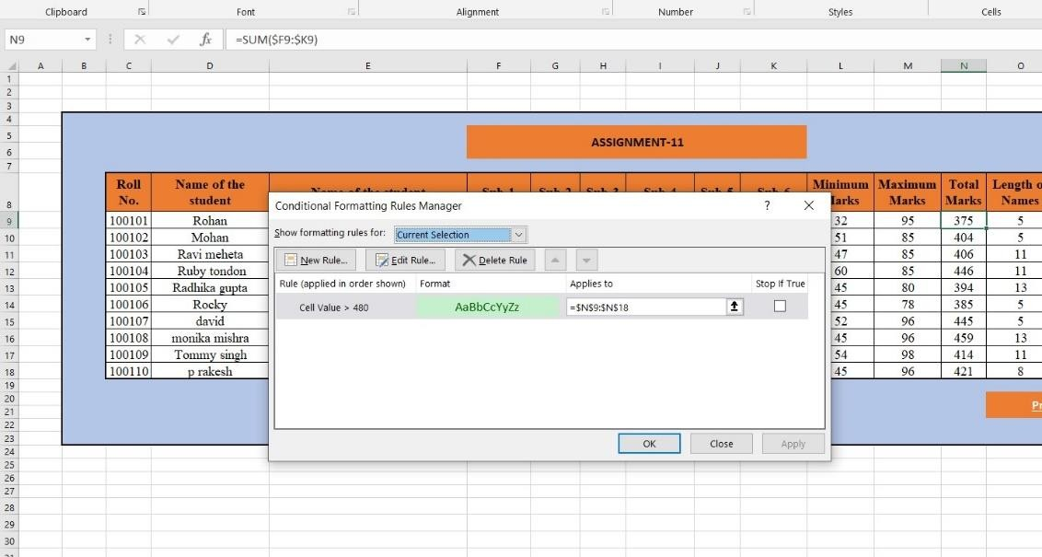

1. Calculate the length of the names of each student.

Ans : Use the formula LEN( ) to get the length of string.

1. Replace the Name Rakhi with Rocky. Use Formulas

Ans : Use “Ctrl” + “F” to get the find pop up window and go to replace tab and search the text/number to be replaced and replace them with new text/number as per the requirements.

1. Combine the Roll Numbers and Names. Use formulas. The end result should look like below.

100101Rohan

Ans : Use the CONCAT( ) formula to join two or more string values.

1. As you can see that some names have spacing issues. Use Formulas to correct that spacing. Also ensure that the names and surnames start with a capital letter.

Ans : we can use TRIM( ) function along with PROPER( ) function to trim the extra space in between and simultaneously capitalise the First name and Last name.

* Excel sheet solution for this assignment [Click Here](https://github.com/rakesh9437/Advance-Excel-Assignments/blob/main/Advance_Excel_11.xlsx)